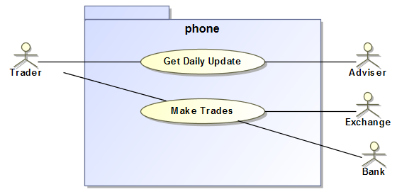

The Trader first gets daily update, decides on what trades to make, then proceeds to make trades.

The Adviser provides the daily update, the exchange and bank provide means to make trades.

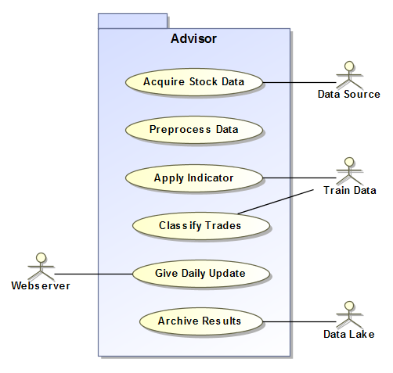

The Adviser system incorporates a variety of things supporting daily update generation.

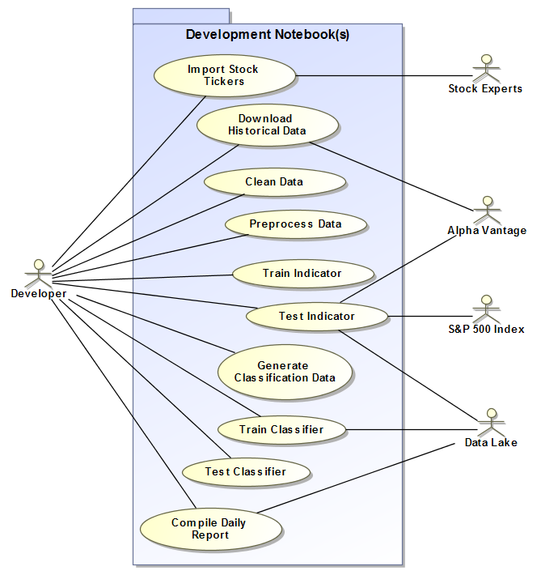

The developer addresses details needed to build the adviser functions.

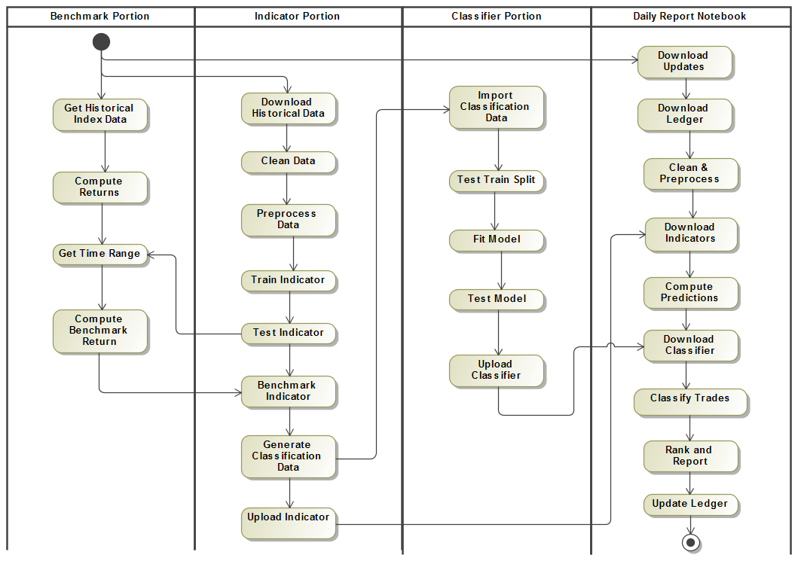

A modular approach is used to break down various Adviser functions.

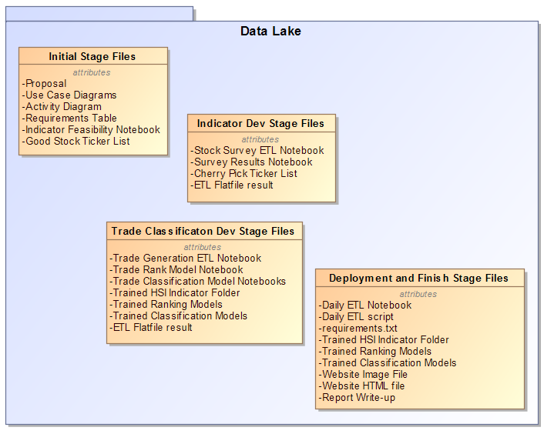

The data lake is built to complement the project development stages.



The Adviser operates as an ETL process composed of eight basic building blocks.

1. The downloader extracts data from the data source.

In this case the data is adjusted close which incorporates stock splits and dividends.

1. The Cleaner starts the data transformation. It conditions the data for preprocessing.

The adjusted close is used to appropriately scale Open, High, Low, Close features.

1. The preprocessor converts market price versus time movements into shape features.
2. The indicator converts shape features into a timewise varying indicator trace.
3. The trade identifier compares the indicator to threshold levels to build trade signals.
4. The classifier assesses trade signals for probability of being a high return trade.

Trade opportunities are compiled for downstream reporting.

1. The formatter rank sorts the trade opportunities based on probability.
2. The reporter loads ranked opportunities to the webserver.

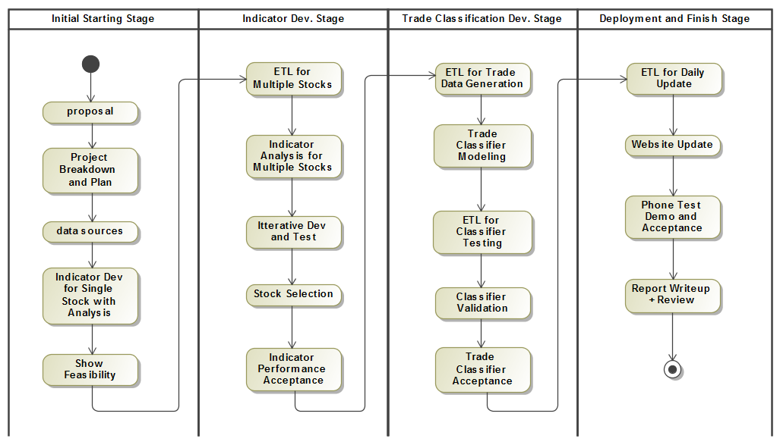

The project is split up into stages where later stages grow dependent on the earlier stages. For this reason, the stages are approached sequentially. As problems arise, the stages are iteratively refactored until the stage workflows work congruently.